Hello and thank you for attending Webelos GO!, the Webelos recruiting event for Thunderbird District Boy Scouts
What is a Host Troop? In order to attend Webelos Woods, the Webelos and their adult partners must be the guest of Boy Scout Troop. This Troop is considered their HOST TROOP. The Webelos will camp with, eat with, and participate in games with their HOST TROOP. Host troops will also provide their Webelos with a 6-inch lanyard which may be hung from a belt loop or pocket flaps, and visiting troops will give each Webelos who visits them a small totem (small enough that up to 8 totems can fit on a 6-inch lanyard).
Registration: You can find event information and a link to doubleknot registration at this link . Troops are asked to follow their usual process and register together as a unit. At the discretion of the Host troop, Webelos packs or families may register individually, or may provide their information to the Host Troop register together with the host troop. For registration questions, contact thunderbird.district.events@gmail.com
Here is the information required to complete registration:
- Troops will register the names of participants, identify the SM or acting SM, and identify the scouts acting as Troop Guide, Emcee, Bugler, and SPL for this event.
- Webelos will need to identify their Webelos Rank, Patrol name, and Host Troop. Most importantly, they will list Troops they'd like to visit during the event. To find out more about troops, visit www.BeAScout.Scouting.org .
Troops indicating participation in this event, including the primary meeting location:
Troop 10 - Church of the Nazarene  Troop 20 - Bethany Lutheran  Troop 61 - Austin Ridge Bible Church  Troop 78 – Austin Oaks Church  Troop 93 - Holy Cross Lutheran  Troop 256 - Bannockburn Baptist Church | Troop 395 - Shephard of the Hills  Troop 403 - St. Paul  Troop 448 – Shady Hollow Community Center  Troop 505 - Oak Hill United Methodist  Troop 555 - Abiding Love Lutheran
The Emcee and Bugler are new positions in 2016, with new responsibilities. The Emcee will be responsible for recruiting at least one group from his troop to perform a song or skit at the campfire, and will work together with the other troop emcees to host the campfire and introduce the groups performing songs and skits. The Buglers will help with bugle calls for reveille, assembly, and taps, will play “Charge” to signal when it is time to switch stations in the morning. Each bugler will be asked to play at most one reveille, assembly, or taps, so the more volunteer buglers we have the better!

Checking In starts at 6pm on Friday. The preference is for Webelos to travel to the event with their host troop. For those Webelos families with extenuating circumstances, please work with your host troop to confirm alternate arrangements. For check-in or event questions contact Luis Rodriguez Luis.Rodriguez@scouting.org or thunderbird.district.events@gmail.com
- Park in the general parking area. Only the SPL and Scoutmaster will come to the check-in building.
- Once the number of participants is confirmed, the SPL will receive the camp site assignment and troop parking pass and return to the troop to set up the camp site. The parking pass is for the trailer tow vehicle. Only that vehicle can drive to and park at the assigned camp site.
- The Scoutmaster or adult in charge of the Host Troop will complete the check-in process; confirm the individual registered participants, confirm that all the expected scout positions are filled, review health forms of attendees with the Medic, and confirm the current YPT of the adults.
Camp Site: Each Host troop will be assigned a site along the driveway. The troop trailer and tow vehicle may park on one side of the driveway, the round robin activity (A) will be set up immediately in front of the troop's campsite Only the trailer and tow vehicle can park at the assigned camp site. The tow vehicle may NOT come and go. It must remain attached to the trailer, in place. There will be a trailer making periodic rounds from the general parking lot to transport gear to campsites. This will be an imperfect process; your patience will be greatly appreciated.
A special thanks to all of the Crews, Posts, Ships and Venturers who volunteered to make this event possible!!
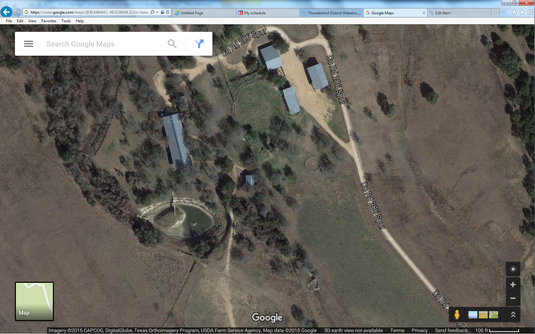
Trailer here
A
Campsite
Checkin
Cracker Barrel
General Parking Area
Games Area

Activities in General. A more precise agenda will be provided at check-in
Friday Night Cracker Barrel open to all leaders beginning at 10:00 p.m.
- 9:00pm Troop Guide meeting in the Cracker Barrel area for all troop guides
- 9:30pm Mandatory unit leader meeting in the Cracker Barrel area for SPL, Emcees, Scoutmaster
Saturday:
- Opening Flag Ceremony
- Webelos Adult Partner discussion about Webelos Transition, Voting instructions for today’s events.
- Troop Guide meeting
- Round Robin
- Lunch
- Games
- Dinner
- Campfire Program
- Troop camp site open house
Sunday Closing and Recognition Ceremony
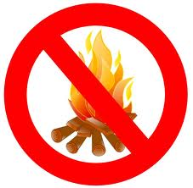
Burn Ban in place, no ground fires allowed. Dutch oven cooking allowed if fires are raised off the ground ONLY. There is no potable water and no showers on site!

